Policy Charges – The Base

Bookings to be made using the online ‘School Spider’ system by 3.30 pm on Friday prior to the following week.

Payment made at the time of the booking.

Bookings not made by 3.30 pm Friday prior to the following week will be classed as ‘ad hoc’ and will incur an extra charge of 50p per session. This will apply to all bookings not made – including free school meal recipients.

Parent to email The Base and School Office to secure ‘ad hoc’ booking.

A charge of £10 per 15 minutes will apply for late collection after club closes
6 pm)

We will not offer a credit in the event that your child is absent.

Term and condition agreements outlining policy are signed by parent/carers.

The following charges will apply:

Morning Session £5.50
After School Session £9.50
Adhoc (per session) £0.50
Late Collection after 6 pm £10.00 (per 15 minutes)
Late Payment Charge £1.00

Details outlining procedures are contained in the Income/Policy Procedure.

Updated/reviewed at Full Governing Body Meeting on the 23 June 2023
Signed (Chair of Governors) 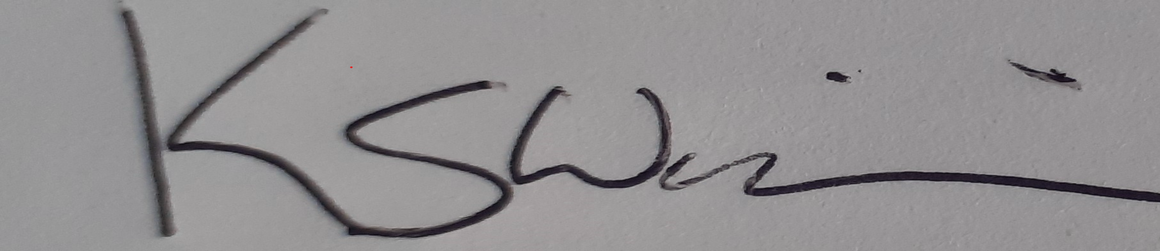 Dated 23 June 2023
Mr Kevin Williams

